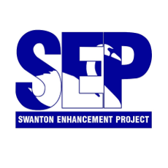

Swanton Enhancement Project

Annual Meeting

We invite all members of the community to attend the Annual Meeting—an event dedicated to fostering local engagement, growth, and success.

Details
- Date: Thursday, September 18, 2025
- Time: 5:30 PM – 7:00 PM
- Location: Swanton Village Municipal Complex, 120 First Street, Swanton, VT
- Serving light hors d’œuvres and pizza for all!

Special Guest Speaker

"Get Down with Your Town! Local Engagement – A Recipe for Community Greatness."
Ted Brady, Executive Director of the Vermont League of Cities and Towns, will talk about the importance of local engagement, with emphasis on Swanton’s leadership and local involvement.

Kilburn-Lambert Award Presentation
The Kilburn-Lambert Award winner will be announced at the meeting.

Additional Agenda Highlights
- SEP Updates
- Community Q&A and open discussion

Each year, Swanton comes together to celebrate the spirit of collaboration and the ongoing efforts to make our community thrive. This upcoming gathering promises not only insightful discussion but also the chance to recognize the individuals and partnerships that have shaped Swanton’s progress. Whether you’re a long-time resident or just beginning to call Swanton home, the Annual Meeting is a unique opportunity to connect, exchange ideas, and learn more about the Swanton Enhancement Project.

